Topic 1: Structures
C program that represents a calendar for a week. Each day has:
dayName (e.g., "Monday")
tasks (array of strings with maximum 3 tasks per day)
Note:
1. Define appropriate structures.
2. Allow the user to input tasks for any day.
3. Display all tasks grouped by the day.
#include <stdio.h>
#include <string.h>

// 1. Define the structure
struct Day {
char dayName[20];
char tasks[3][100]; // Array of strings (Max 3 tasks)
int taskCount; // Stores the number of tasks entered
};

int main() {
// Initialize the array of structures for 7 days
struct Day week[7] = {
{"Monday", {}, 0},
{"Tuesday", {}, 0},
{"Wednesday", {}, 0},
{"Thursday", {}, 0},
{"Friday", {}, 0},
{"Saturday", {}, 0},
{"Sunday", {}, 0}
};

int i, j;

printf("------ WEEKLY CALENDAR ------\n");

// Allow the user to input tasks
for (i = 0; i < 7; i++) {
printf("\nEnter number of tasks for %s (Max 3): ", week[i].dayName);
scanf("%d", &week[i].taskCount);

// Ensure user doesn't exceed the max limit of 3
if (week[i].taskCount > 3) {
printf("Only 3 tasks allowed. Setting to 3.\n");
week[i].taskCount = 3;
}

getchar(); // Clear the hidden newline ('\n') left by scanf from the buffer

// Input each task for the current day
for (j = 0; j < week[i].taskCount; j++) {
printf("Enter task %d: ", j + 1);
fgets(week[i].tasks[j], 100, stdin);

// Remove the trailing newline character added by fgets
week[i].tasks[j][strcspn(week[i].tasks[j], "\n")] = '\0';
}
}

// Display all tasks grouped by the day
printf("\n\n====== WEEKLY TASK SCHEDULE ======\n");
for (i = 0; i < 7; i++) {
printf("\n%s:\n", week[i].dayName);

if (week[i].taskCount == 0) {
printf(" No tasks\n");
} else {
for (j = 0; j < week[i].taskCount; j++) {
printf(" %d. %s\n", j + 1, week[i].tasks[j]);
}
}
}

return 0;
}OUTPUT:

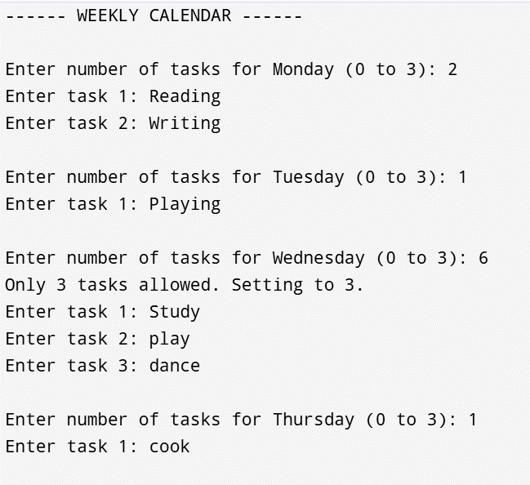
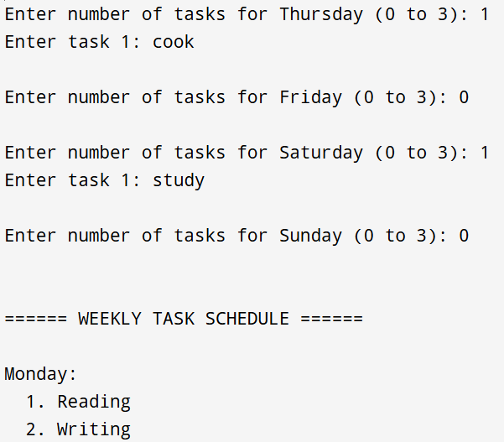
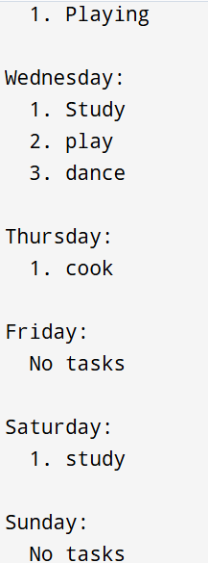
Topic 2: Pointers
Question:
Write a function in C that takes a pointer to an integer array and its size, and then rearranges the array in-place such that all even numbers appear before odd numbers, preserving the original relative order using only pointer arithmetic (no indexing with []).

#include <stdio.h>
void rearrange(int *arr, int n)
{
int temp[n];
int i, j = 0;
// Store even numbers first
for(i = 0; i < n; i++)
{
if(*(arr + i) % 2 == 0){
*(temp + j) = *(arr + i);
j++;
}
}
// Store odd numbers next
for(i = 0; i < n; i++){
if(*(arr + i) % 2 != 0)
{
*(temp + j) = *(arr + i);
j++;
}
} // Copy back to original array
for(i = 0; i < n; i++)
{
*(arr + i) = *(temp + i);
}
}

int main()
{
int n, i;
printf("Enter size of array: ");
scanf("%d", &n);
int arr[n];
printf("Enter array elements:\n");
for(i = 0; i < n; i++)
{
scanf("%d", arr + i);
}
rearrange(arr, n);
printf("Array after rearranging:\n");
for(i = 0; i < n; i++)
{
printf("%d ", *(arr + i));
}
return 0;
}
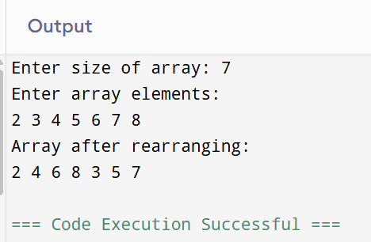

Topic 3: Arrays
Question:
You are given a 2D matrix of size n x n where each row and each column is sorted in increasing order. Write a C function to determine whether a given key exists in the matrix using the most efficient approach.

#include <stdio.h>
void searchMatrix(int arr[10][10], int n, int key)
{
int i = 0;
int j = n - 1;
// Start from top-right corner
while(i < n && j >= 0)
{
if(arr[i][j] == key)
{
printf("Key found at position (%d , %d)", i, j);
return;
}
else if(arr[i][j] > key)
{
j--; // Move left
}
else
{
i++; // Move down
}
}
printf("Key not found");
}

int main()
{
int n, i, j, key;
int arr[10][10];
printf("Enter size of matrix: ");
scanf("%d", &n);
printf("Enter matrix elements:\n");
for(i = 0; i < n; i++)
{
for(j = 0; j < n; j++)
{
scanf("%d", &arr[i][j]);
}
}
printf("Enter key to search: ");
scanf("%d", &key);
searchMatrix(arr, n, key);
return 0;
}

